TABLE OF CONTENTS

1. INTRODUCTION 4
1.1 BACKGROUND OF THE STUDY 4
1.2 OBJECTIVES OF THE STUDY 5
1.3 SCOPE OF THE PROJECT 5
2 SOFTWARE REQUIREMENT ANALYSIS 7
2.1 HARDWARE SPECIFICATION 7
2.2 SOFTWARE SPECIFICATION 7
3. SYSTEM ANALYSIS 8
3.1 REQUIREMENT SPECIFICATION 8
Functional Requirements 8
3.2 Characteristics of Existing System 9
3.3 Feasibility Study 9
4. SYSTEM DESIGN 11
4.1 SYSTEM ARCHITECTURE 11
4.2 SYSTEM ARCHITECTURE DIAGRAM 11
4.3 USE CASE DIAGRAM 12
4.4 ACTIVITY DIAGRAM 13
4.5 CLASS DIAGRAM 14
4.6 DATA FLOW DIAGRAM (DFD) 15
4.7 ER DIAGRAM 16
5. SYSTEM IMPLEMENTATION 17
5.1 MODULE DESCRIPTION 17
5.2 VALIDATION CHECKS 18
6. TESTING 20
6.1 INTRODUCTION TO TESTING 20
7. RESULT AND CONCLUSION 24
8. APPENDICES 27
8.1 SCREEN SHOTS 27
8.2 SAMPLE CODING 35
9. REFERENCES 55
9.1 BOOK REFERENCES 55

ABSTRACT
In the modern digital landscape, web applications are widely used across various domains such as education, banking, healthcare, and e-commerce. However, the increasing dependency on these applications has also led to a rise in cybersecurity threats, particularly due to weak password practices and inadequate monitoring of login activities. Many users tend to use simple and predictable passwords, making systems highly vulnerable to attacks such as brute force, dictionary attacks, and credential stuffing. Addressing these challenges, this project titled “Password Strength Analysis and Login Security Monitoring System” focuses on enhancing authentication security through real-time password evaluation and login activity monitoring.
The proposed system is designed to analyse the strength of user passwords dynamically based on multiple parameters including length, use of uppercase and lowercase characters, numerical digits, special symbols, and resistance to common patterns. It provides immediate feedback to users through a visual strength indicator and security checklist, encouraging the creation of strong and secure passwords.
This project not only demonstrates the importance of strong password policies but also simulates basic intrusion detection mechanisms in a controlled environment. It serves as an effective learning model for understanding real-world security practices and highlights the need for integrating both preventive and monitoring strategies in web application security. The system can be further enhanced with advanced features such as multi-factor authentication, encryption techniques, and machine learning-based anomaly detection for improved protection.

LIST OF FIGURES

Figure 1:SYSTEM ARCHITECTURE 11
Figure 2: CONTEXT DIAGRAM 12
Figure 3:DATA FLOW DIAGRAM 15
Figure 4:ER DIAGRAM 16
Figure 5:HOME INTERFACE OF THE SYSTEM 29
Figure 6:REAL - TIME PASSWORD INPUT ANALYSIS 29
Figure 7:WEAK PASSWORD DETECTION 30

INTRODUCTION
In today’s digital era, web applications have become an essential part of everyday life, supporting services such as online banking, education platforms, social media, and e-commerce. As the usage of these applications increases, so does the risk of cybersecurity threats. One of the most common vulnerabilities in web systems is weak password management and lack of proper monitoring of login activities. Many users tend to create simple, predictable passwords, which can be easily exploited by attackers using techniques such as brute force attacks, dictionary attacks, and credential stuffing.
To address these issues, this project titled “Password Strength Analysis and Login Security Monitoring System” is designed to enhance the security of authentication mechanisms in web applications. The system focuses on two key aspects: evaluating password strength in real time and monitoring login attempts to detect suspicious behaviour. By analysing password complexity based on predefined rules and providing immediate feedback, users are encouraged to create stronger and more secure credentials.

BACKGROUND OF THE STUDY
With the rapid growth of digital technologies, web-based systems have become the backbone of modern communication, business operations, and data management. From online banking to educational platforms and social networking services, users are required to authenticate themselves through login systems, primarily using usernames and passwords. However, despite advancements in technology, password-based authentication remains one of the weakest links in cybersecurity due to poor user practices and lack of effective monitoring mechanisms.
Studies and real-world incidents have shown that a significant number of users continue to use weak, easily guessable passwords such as common words, simple patterns, or reused credentials across multiple platforms. This behaviour increases the risk of cyberattacks, including brute force attacks, dictionary attacks, and credential stuffing, where attackers exploit leaked password databases to gain unauthorized access. According to cybersecurity reports, compromised credentials are one of the leading causes of data breaches worldwide.
The proposed project, “Password Strength Analysis and Login Security Monitoring System,” is developed based on this need. It aims to bridge the gap between password security and real-time monitoring by providing a system that evaluates password strength dynamically and detects suspicious login behaviour. By combining these features, the project contributes to creating a more secure and aware authentication environment, reflecting real-world cybersecurity practices in a simplified and practical manner.

OBJECTIVES OF THE STUDY
The main objectives of the proposed project, “Password Strength Analysis and Login Security Monitoring System,” are as follows:

  - To design and develop a web-based system that evaluates password strength in real time based on predefined security parameters such as length, complexity, and uniqueness.
  - To provide immediate visual feedback to users through a strength indicator and security checklist, encouraging the creation of strong and secure passwords.
  - To detect weak and commonly used password patterns that are vulnerable to attacks such as brute force and dictionary attacks.
  - To implement a login monitoring mechanism that tracks user authentication attempts and identifies suspicious activities such as repeated failed logins.
  - To generate alerts when abnormal login behaviour is detected, simulating a basic intrusion detection system.

SCOPE OF THE PROJECT
The project focuses on developing a web-based application for password strength analysis and login monitoring.

The system analyses passwords in real time based on parameters such as:

- Length
- Uppercase and lowercase characters
- Numbers
- Special characters

It provides instant feedback through a strength indicator and checklist to help users create secure passwords.

The system includes a login monitoring module that:
- Tracks login attempts
- Detects repeated failed logins
- Identifies suspicious behaviour

The system maintains a database to store:
- Password analysis results
- Login attempts
- Security alerts

2 SOFTWARE REQUIREMENT ANALYSIS

2.1 HARDWARE SPECIFICATION
  - Processor: Intel Core i3 or higher / equivalent AMD processor
  - RAM: Minimum 4 GB (Recommended: 8 GB or higher)
  - Storage: At least 20 GB free disk space
  - System Type: Laptop or Desktop
  - Display: Standard monitor with minimum resolution support
  - Network: Internet connection (for development and testing purposes)

2.2 SOFTWARE SPECIFICATION
  - Operating System: Kali Linux / Windows 10 or higher
  - Programming Language: Python
  - Web Framework: Flask
  - Frontend Technologies: HTML, CSS, JavaScript
  - Database: SQLite
  - Browser: Google Chrome / Mozilla Firefox
  - Code Editor / IDE: VS Code / Sublime Text

SYSTEM ANALYSIS

REQUIREMENT SPECIFICATION

Functional Requirements
- The system should allow users to enter username and password through a web interface.
- The system should analyse password strength based on:
  - Length
  - Uppercase and lowercase letters
  - Numbers
  - Special characters
- The system should provide real-time feedback on password strength.
- The system should monitor login attempts.
- The system should detect multiple failed login attempts.
- The system should generate alerts for suspicious login behaviour.
- The system should store:
  - Login attempts
  - Password analysis results
  - Alerts
- The system should display data in a dashboard view.
- The system should allow exporting data in CSV format

Non-Functional Requirements
- Performance: The system should provide fast and real-time feedback.
- Usability: The interface should be simple and user-friendly.
- Reliability: The system should function without crashes during usage.
- Scalability: The system should be extendable with additional features.
- Security: Basic validation and monitoring should be implemented.

Characteristics of Existing System
- Most systems only perform basic password validation (minimum length).
- No real-time feedback is provided to users.
- Lack of password strength analysis.
- No monitoring of login attempts.
- No alert mechanism for suspicious activities.
- Systems do not maintain detailed logs for analysis

Feasibility Study
Technical Feasibility
- The project uses simple technologies like Python, Flask, and SQLite.
- No advanced hardware or software is required.
- Easy to implement and maintain.
Economic Feasibility
- Uses open-source tools (no licensing cost).
- Low development and maintenance cost.
- Suitable for academic and small-scale applications.
Operational Feasibility
- Easy to use interface.
- Requires minimal user training.
- Can be operated by non-technical users.
Legal Feasibility
- The system does not collect sensitive real-world data.
- Designed for educational purposes.
- No violation of privacy or legal regulations.

SYSTEM DESIGN

SYSTEM ARCHITECTURE
The system architecture of the Password Strength Analysis and Login Security Monitoring System is designed to provide a structured flow of data between the user interface, processing modules, and database. The system follows a client-server model where the user interacts with the frontend, and the backend processes the data and stores it in the database.

The user enters credentials through the web interface. The password is analysed in real time using predefined rules to determine its strength. Simultaneously, the login monitoring module tracks the number of login attempts. If multiple failed attempts are detected, the system generates alerts and stores the information in the database. The dashboard module retrieves stored data and displays it in a visual format.

SYSTEM ARCHITECTURE DIAGRAM
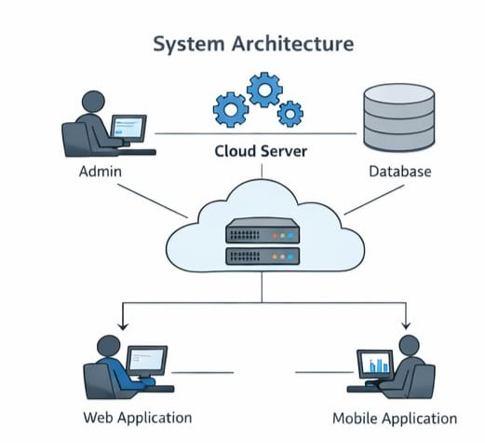
Figure 4.1: System Architecture of Password Strength Analysis and Login Security Monitoring System

USE CASE DIAGRAM

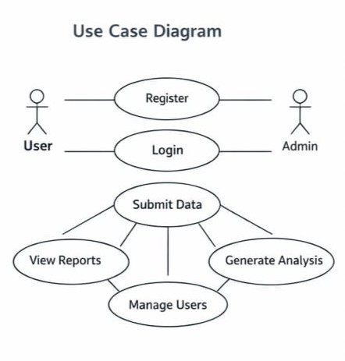
FIGURE 4:2 USE CASE DIAGRAM

The Use Case Diagram represents the interaction between the user and the system. In this system, the primary actor is the User, who interacts with different functionalities provided by the application.
The user performs actions such as entering a password, analysing its strength, attempting login, and viewing the dashboard. The system processes these actions and provides appropriate responses, such as displaying password strength, detecting suspicious login attempts, and generating alerts. Additionally, the system allows exporting data for further analysis.

ACTIVITY DIAGRAM

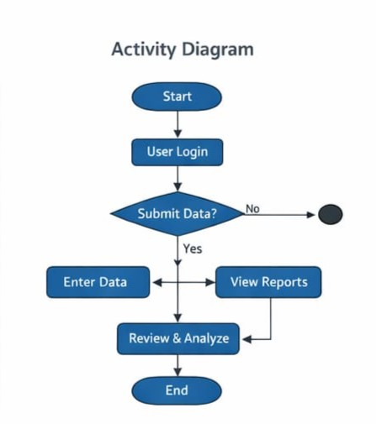
Figure 4.4:Activity Diagram
The Activity Diagram illustrates the step-by-step workflow of the system from input to output. It begins with the user entering a username and password, followed by the system analysing the password strength.
Based on the strength evaluation, the system may provide feedback if the password is weak. The user then attempts to log in, and the system checks whether the credentials are valid. If the login is successful, access is granted; otherwise, the system increments the failed attempt count.
If the number of failed attempts exceeds a predefined limit, an alert is generated. This diagram clearly shows the decision-making process and flow of control within the system.

CLASS DIAGRAM

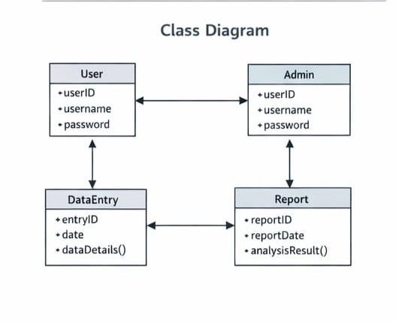
Figure 4.5:Class Diagram
The Class Diagram represents the structural design of the system by showing different classes, their attributes, and methods.
The main classes in the system include:
User, which stores user credentials
PasswordAnalyzer, which handles password validation and strength checking
Login Monitor, which tracks login attempts and detects suspicious behaviour
Database.

DATA FLOW DIAGRAM (DFD)

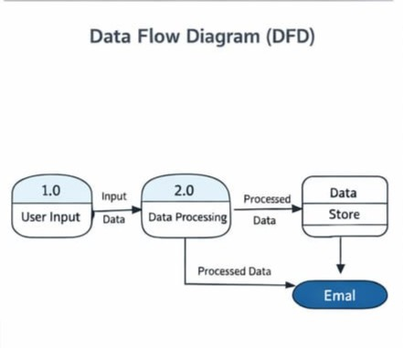
Figure 4.6:Data Flow Diagram
The Data Flow Diagram (DFD) illustrates how data moves through the system.
At Level 1, it shows a simple flow where the user provides input, the system processes it, and the output is generated and stored in the database.
At Level 2, the process is broken down into detailed steps such as password analysis, login monitoring, and alert generation. The processed data is then stored in the database and used for generating reports.
This diagram helps in understanding how data is handled and transformed within the system.

ER DIAGRAM

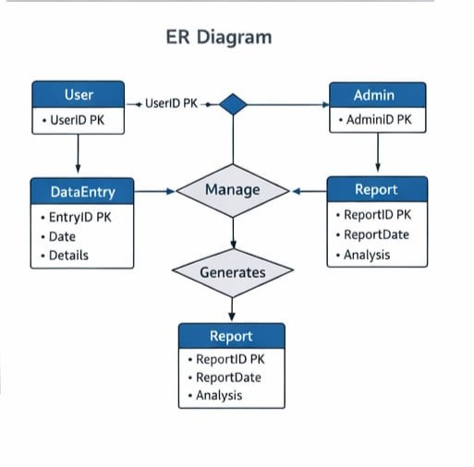
Figure 4.7 ER Diagram
The Entity-Relationship (ER) Diagram represents the database structure of the system.
The main entities include:
User, which contains user information
Login Attempts, which records login activities
Alerts, which stores suspicious activity logs
There is a relationship where one user can have multiple logins attempts and multiple alerts. This diagram helps in visualizing how data is stored and how different entities are related within the database.

SYSTEM IMPLEMENTATION

MODULE DESCRIPTION
The Password Strength Analysis and Login Security Monitoring System is implemented using a modular approach, where each module performs a specific function. The system is developed using Python (Flask framework) for backend processing, along with HTML, CSS, and JavaScript for frontend design, and SQLite for data storage.
1. User Interface Module
- Provides input fields for username and password
- Displays password strength in real time
- Shows alerts and feedback messages
- Built using HTML, CSS, and JavaScript
2. Password Analysis Module
- Evaluates password strength based on:
- Length
- Uppercase and lowercase letters
- Numbers
- Special characters
- Assigns risk levels:
- Critical
- High
- Medium
- Low
Generates suggestions for improving password
3. Login Monitoring Module
- Tracks login attempts for each user
- Increments attempt count on failure
- Detects suspicious activity when:
- Multiple failed attempts occur
- Generates alerts when threshold is exceeded
4. Alert Management Module
Stores alert details in database
Records:
- Username
- Event type
- Time of occurrence
- Helps simulate intrusion detection
5. Database Module
Uses SQLite database
Stores:
- Analysis results
- Login attempts
- Alerts
Ensures efficient data retrieval and storage
6. Dashboard Module
Displays summary of:
- Total analyses
- Risk levels
- Alerts
- Provides visual representation of system data
7. Export Module
Allows exporting data in CSV format
Used for reporting and documentation

VALIDATION CHECKS
The system includes basic validation mechanisms to ensure proper input handling and improve security.

Input Validation
- Ensures username and password fields are not empty
- Prevents invalid or incomplete data submission
Password Validation
- Checks minimum length requirement
- Verifies inclusion of:
- Uppercase letters
- Lowercase letters
- Numbers
- Special characters
Login Validation
- Verifies username and password correctness
- Tracks failed login attempts
- Restricts access after multiple failures
Security Validation
- Detects suspicious login behaviour
- Generates alerts for abnormal activity
- Maintains logs for monitoring

TESTING

INTRODUCTION TO TESTING
Testing is a critical phase in software development that ensures the system functions correctly and meets the specified requirements. It helps in identifying errors, verifying system performance, and ensuring reliability. In this project, testing is carried out to validate the functionality of password analysis, login monitoring, alert generation, and data handling mechanisms.

The testing process ensures that the system behaves as expected under different conditions, including valid inputs, invalid inputs, and edge cases. Both functional and non-functional testing approaches are applied to evaluate system performance, usability, and correctness.

  - Test Case Design

Test cases are designed to verify individual functionalities of the system. Each test case includes input conditions, expected output, and actual results.
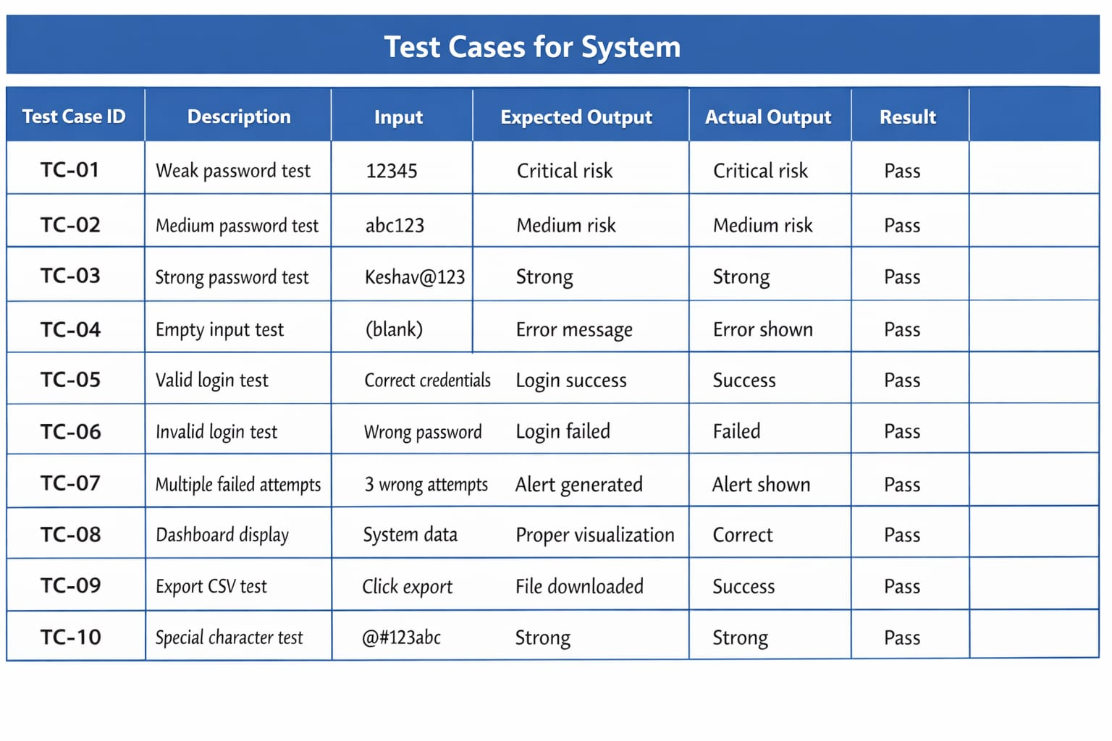

Figure 6.1 :Test Case For System
Explanation of Test Cases

The above test case table represents the systematic validation of the Password Strength Analysis and Login Security Monitoring System. Each test case is designed to verify a specific functionality of the system under different input conditions.
The test cases include various scenarios such as weak, medium, and strong password inputs to evaluate the accuracy of the password strength analysis module. It ensures that the system correctly classifies passwords based on complexity and provides appropriate feedback to the user.

Additionally, login-related test cases are included to verify the authentication mechanism. These tests check both valid and invalid login attempts, ensuring that the system correctly grants or denies access. The system also monitors multiple failed logins attempts and generates alerts when suspicious behaviour is detected, validating the effectiveness of the login monitoring module.

Other test cases focus on system features such as dashboard display and data export functionality. These ensure that the system correctly retrieves, processes, and presents data to the user.

Overall, the results indicate that the system performs as expected under different conditions, and all test cases have passed successfully. This confirms the reliability, correctness, and effectiveness of the implemented modules.

  - UNIT TESTING
Unit testing is performed to verify individual modules of the system independently. Each module is tested in isolation to ensure that it functions correctly.

Password Analysis Module Testing
- Checked password strength calculation
- Verified rule-based validation
- Tested different combinations of inputs
- Ensured accurate risk classification

Login Monitoring Module Testing
- Verified tracking of login attempts
- Checked increment of failed attempts
- Tested alert generation after threshold
- Ensured reset after successful login

Alert Module Testing
- Verified alert creation and storage
- Checked alert display functionality
- Ensured correct event logging

Database Module Testing
- Tested data insertion and retrieval
- Verified storage of login attempts and alerts
- Ensured no data loss

  - INTEGRATION TESTING
Integration testing ensures that all modules work together correctly as a complete system.

System Flow Testing
- User enters password → system analyses → result displayed
- User attempts login → system verifies → response generated

Login + Alert Integration
- Multiple failed attempts trigger alert
- Alert stored in database
- Alert displayed in UI

Dashboard Integration
- Data from database is retrieved
- Displayed correctly in dashboard
- Metrics updated dynamically

Export Module Integration
- Data collected from database
- Converted to CSV
- File downloaded successfully

  - RESULT ANALYSIS
The testing results show that the system performs efficiently under various scenarios. All modules function as expected, and no major errors were identified during testing.
- Password strength analysis is accurate
- Login monitoring works correctly
- Alerts are generated appropriately
- Data storage and retrieval are reliable

  - LIMITATIONS IN TESTING
Testing performed in controlled environment
No real-world attack simulation

RESULT AND CONCLUSION
  - RESULT
The Password Strength Analysis and Login Security Monitoring System was successfully designed and implemented using Python (Flask), HTML, CSS, JavaScript, and SQLite database. The system was tested under various scenarios to evaluate its performance, functionality, and reliability.
The results demonstrate that the system effectively analyses password strength in real time based on predefined parameters such as length, complexity, and character diversity. It provides accurate feedback to users, encouraging the creation of secure passwords. The password strength classification into different risk levels (Critical, High, Medium, and Low) was found to be consistent and reliable.

The login monitoring module performed efficiently by tracking user login attempts and detecting suspicious behaviour such as multiple failed login attempts. The system successfully generated alerts when predefined thresholds were exceeded, simulating a basic intrusion detection mechanism. All alerts were properly recorded and stored in the database for further analysis.

The dashboard module displayed key metrics such as total analyses, risk levels, and alert counts accurately. The data export functionality also worked as expected, allowing users to download system data in CSV format for reporting purposes.
Overall, the system functioned correctly across all modules, and all test cases were successfully passed. The results confirm that the system meets its intended objectives and provides a practical demonstration of basic web security mechanism.

  - FUTURE ENHANCEMENTS
The current system provides a foundational implementation of password analysis and login monitoring. However, several advanced features can be incorporated to enhance the system’s security, scalability, and real-world applicability.
Security Enhancements
- Implementation of password hashing and encryption techniques (e.g., crypt, SHA-256) to securely store user credentials.
- Integration of multi-factor authentication (MFA) such as OTP, biometric verification, or authenticator apps to strengthen user authentication.
- Use of secure communication protocols (HTTPS/SSL) to protect data transmission between client and server.

Advanced Threat Detection
- Incorporation of machine learning algorithms to detect unusual login patterns and predict potential security threats.
- Implementation of behaviour-based anomaly detection, analysing user login time, frequency, and patterns.
- Detection of credential stuffing attacks using pattern recognition techniques.

Real-Time Alert System
- Integration of email and SMS notifications for instant alerting of suspicious login attempts.
- Development of push notifications for real-time updates to users and administrators.

Scalability Improvements
- Migration from SQLite to advanced databases such as MySQL or PostgreSQL for handling large-scale data.
- Deployment on cloud platforms such as AWS, Azure, or Google Cloud for better scalability and availability.

User Management System
- Implementation of a complete user authentication system with registration, login, and role-based access control.
- Addition of admin dashboard for monitoring multiple users and system activities.

Enhanced User Interface
- Improvement of UI/UX with modern frameworks such as React or Angular.
- Addition of interactive charts and graphs for better visualization of security metrics.

Integration with Security Tools
- Integration with SIEM (Security Information and Event Management) systems for centralized monitoring.
- Compatibility with tools like Splunk or ELK Stack for advanced log analysis.

Automation and Testing Enhancements
- Implementation of automated testing frameworks for continuous system validation.
- Use of CI/CD pipelines for continuous deployment and updates.

Cross-Platform Support
- Development of mobile application versions (Android/iOS) for accessibility

APPENDICES

SCREEN SHOTS

    - Kali terminal

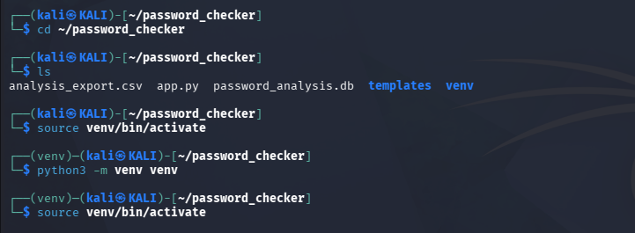
Figure 8.1.1: project folder structure of the system

This is the login terminal of kali where is start up the environment to create a space to arrange the password checker.
- Once it created it check the analysis part to run the play load and create the app.py work space in the templates venv

Using the venv/bin/activate where the work-space to active the app and the run the website.

Python3 -m venv evnv where the whole programming files will be saved and ready to executed and the files will set into the program file
Source ven/bin/activate

Activates isolated Python runtime
Changes terminal prompt → indicates active environment
Ensures all installed packages go inside venv

The screenshot shows the Kali Linux terminal where the virtual environment is activated successfully. The project directory password checker is initialized, and the environment is prepared for executing the application. This step ensures that all dependencies are loaded in an isolated workspace before running the password checker application.

    - LOGIN TO THE APP.PY

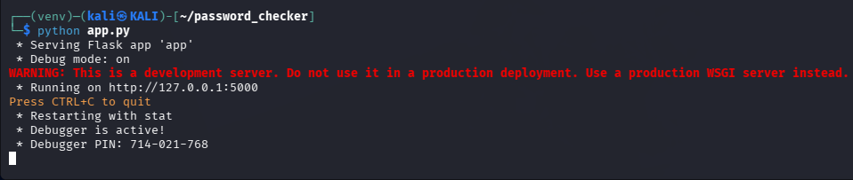
Figure 8.1.2: Execution of Flask Application in Terminal

- The screenshot shows the execution of the app.py file in the Kali Linux terminal.
- The application is started using the command python app.py.
- Flask framework initializes a local development server.
- The server runs on http://127.0.0.1:5000/, which can be accessed through a web browser.
- Debug mode is enabled, allowing detection and display of errors during development.
- The terminal output confirms that the application is successfully running.
- The server automatically reloads when changes are made to the code.
- This step ensures that the backend logic of the password checker is active.
- Users can now interact with the application through the web interface.
- The local server acts as a testing environment before deployment.
The Flask framework handles incoming HTTP requests and renders the corresponding templates for user interaction. The local server acts as a testing environment before deploying the application in a production setup.
app.py file in the Kali Linux terminal. The Flask application is started using the command python app.py, which initializes the local development server. The output confirms that the application is running on http://127.0.0.1:5000/, allowing the user to access the password checker through a web browser

    - HOME INTERFACE OF THE SYSTEM
Figure 5:HOME INTERFACE OF THE SYSTEM

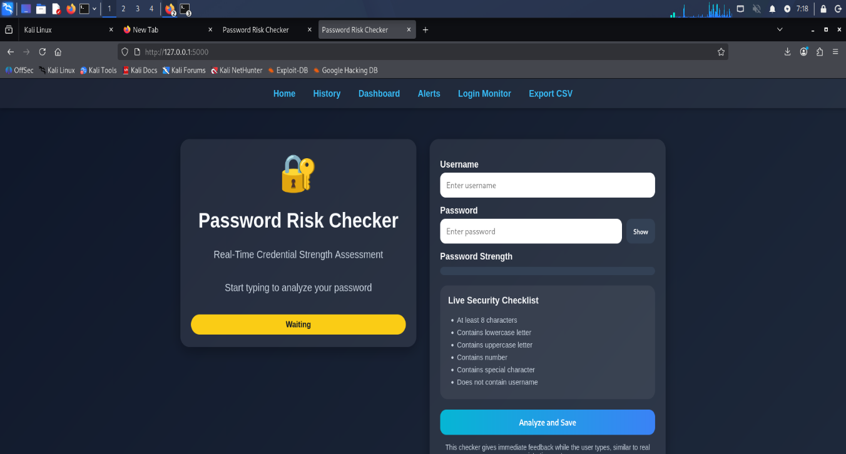
Figure 8.1.3: Home Interface of the Password Risk Checker

    - REAL-TIME PASSWORD INPUT ANALYSIS
Figure 6:REAL - TIME PASSWORD INPUT ANALYSIS
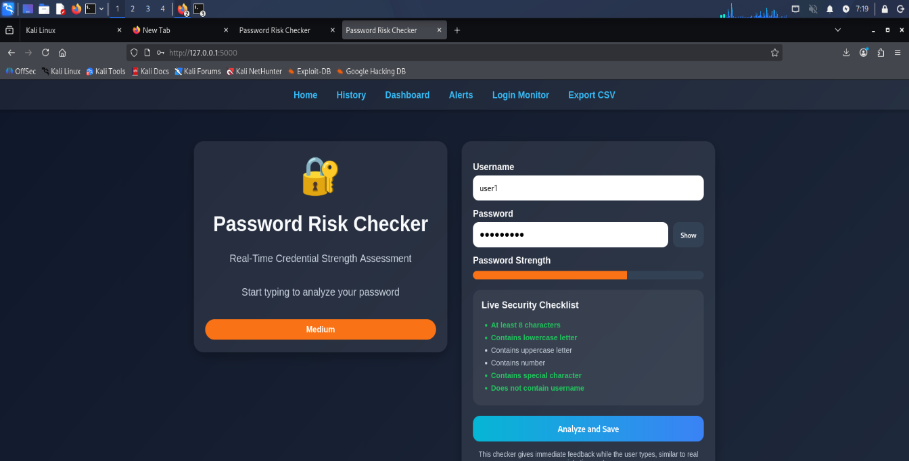
Figure 8.1.4: Live password Strength Analysis

    - WEAK PASSWORD DETECTION
Figure 7:WEAK PASSWORD DETECTION

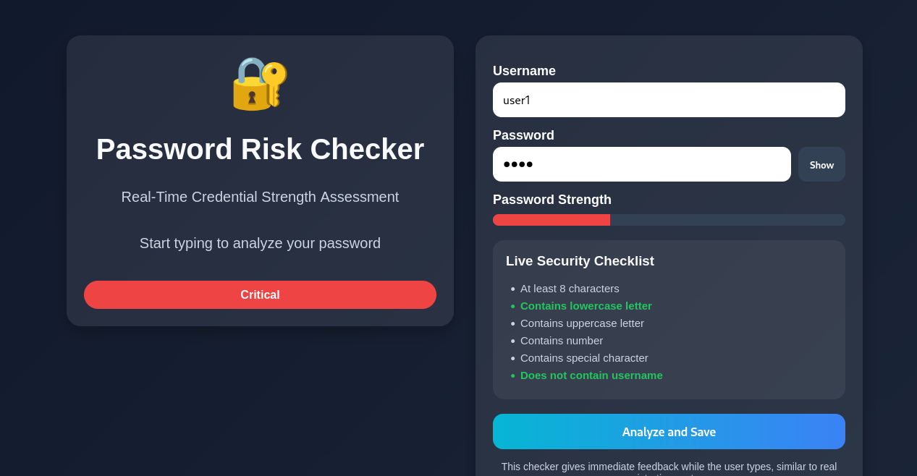
Figure 8.1.5: Weak Password Classified as Critical Risk
    - STRONG PASSWORD DETECTION

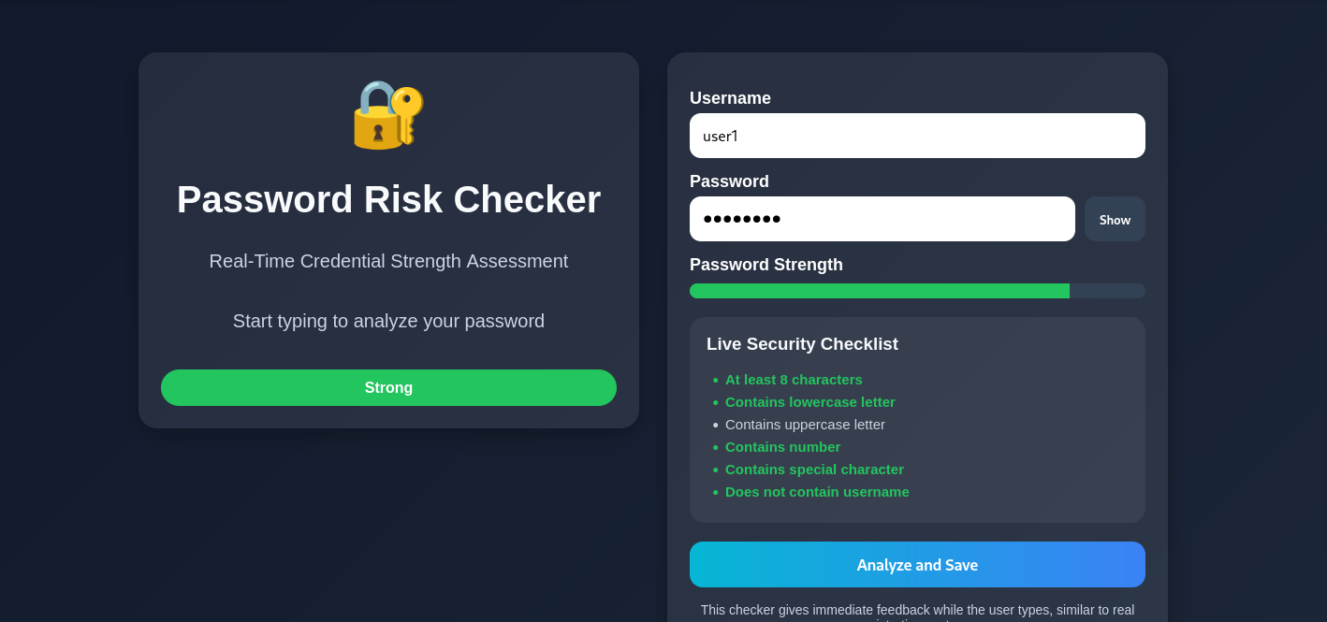
Figure 8.1.6: Strong Password Identified as Low Risk

    - LOGIN INTERFACE
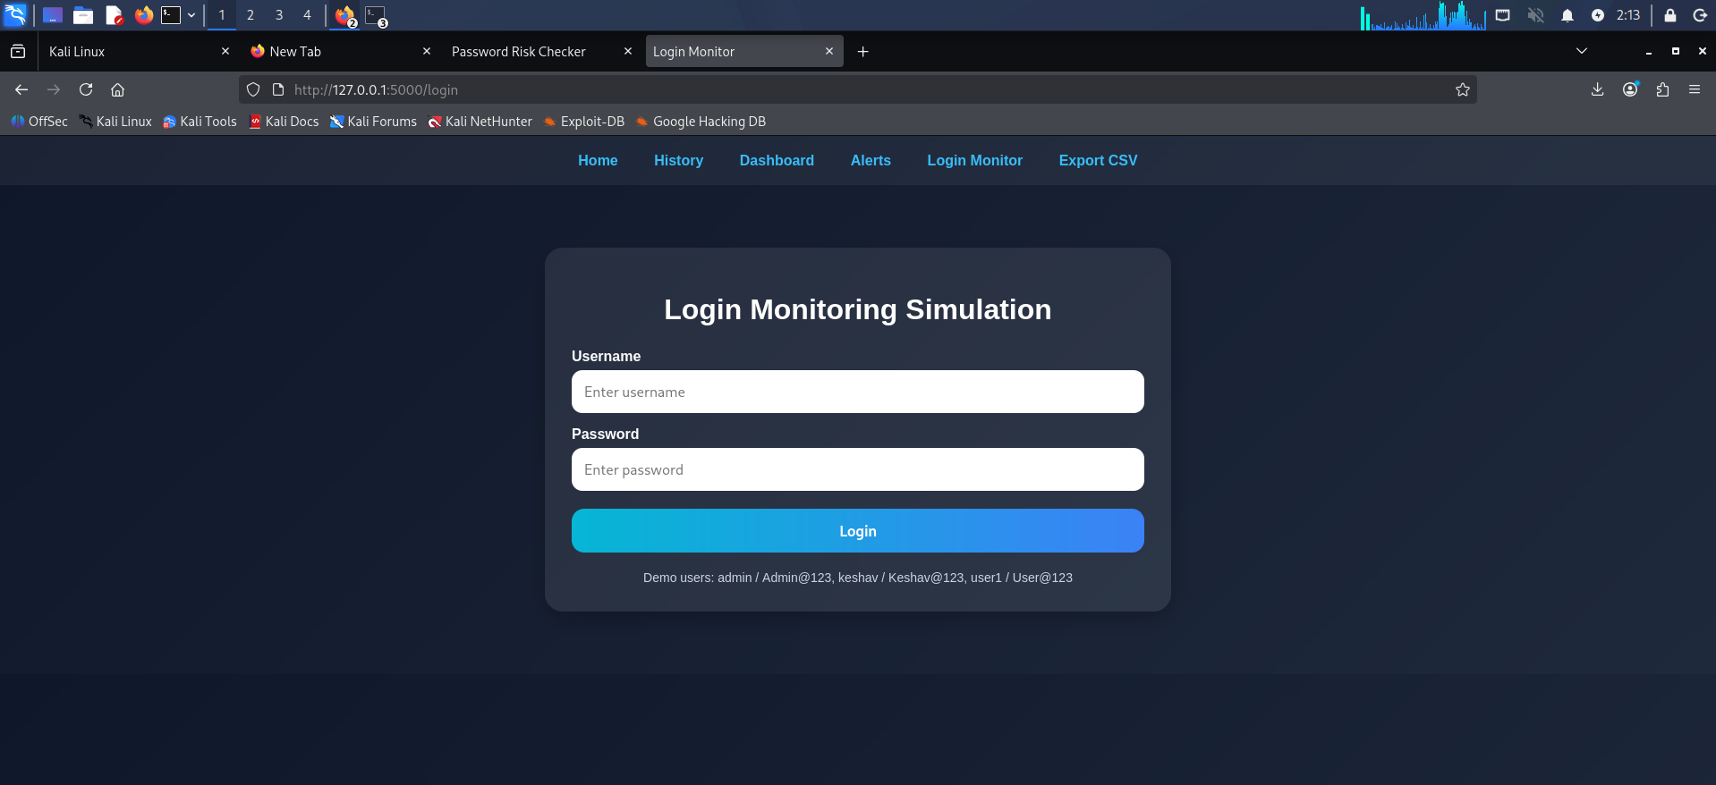
Figure 8.1.7: Login Interface of the System

    - AILED LOGIN ATTEMPT
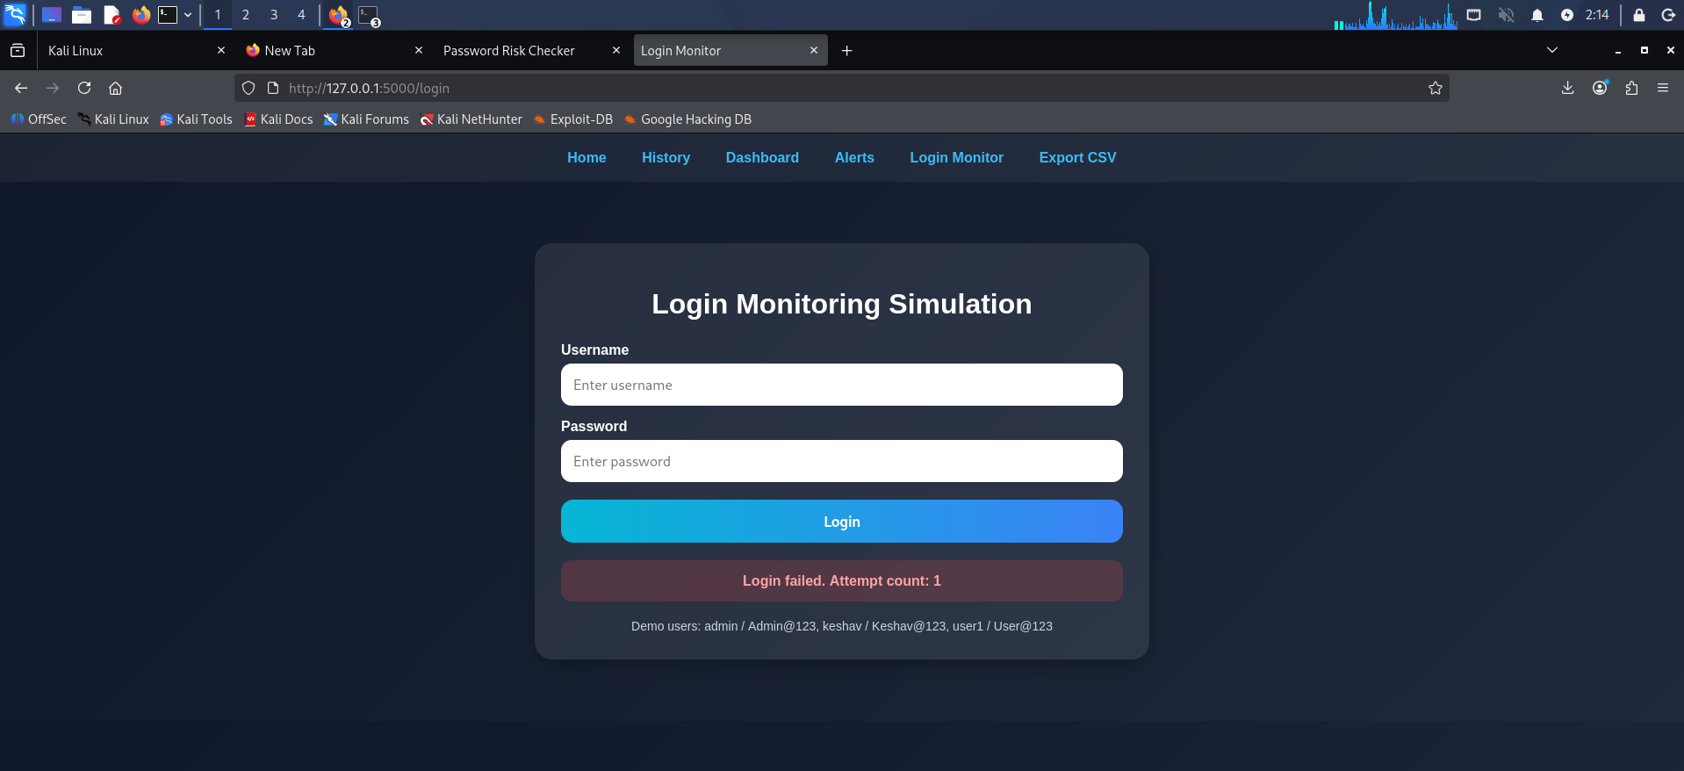

    - MULTIPLE FAILED LOGIN ATTEMPTS

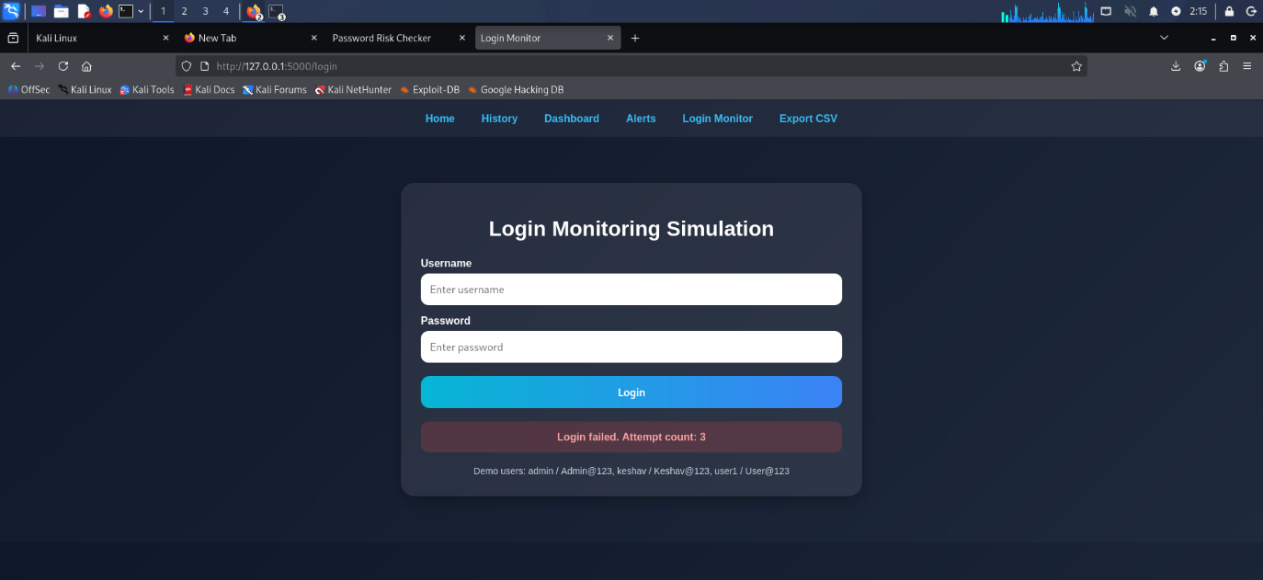
Figure 8.1.9: Multiple Failed Login Attempts Detection
    - ALERT GENERATION

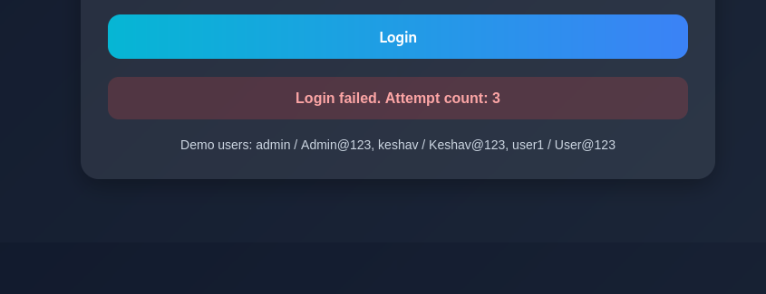
Figure 8.1.10: Alert Generated After Multiple Failed Attempts

    - ALERTS DASHBOARD

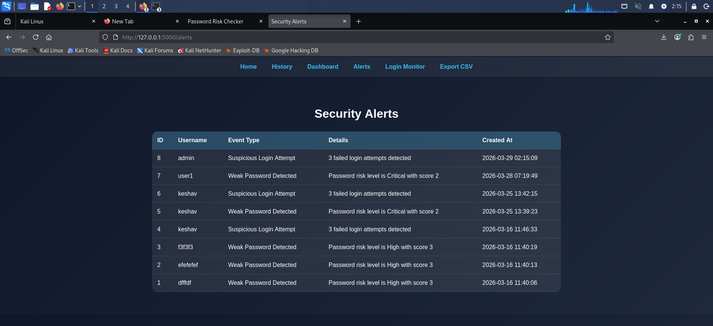
Figure 8.1.11: Alerts Display Page

    - SYSTEM DASHBOARD / ANALYTICS

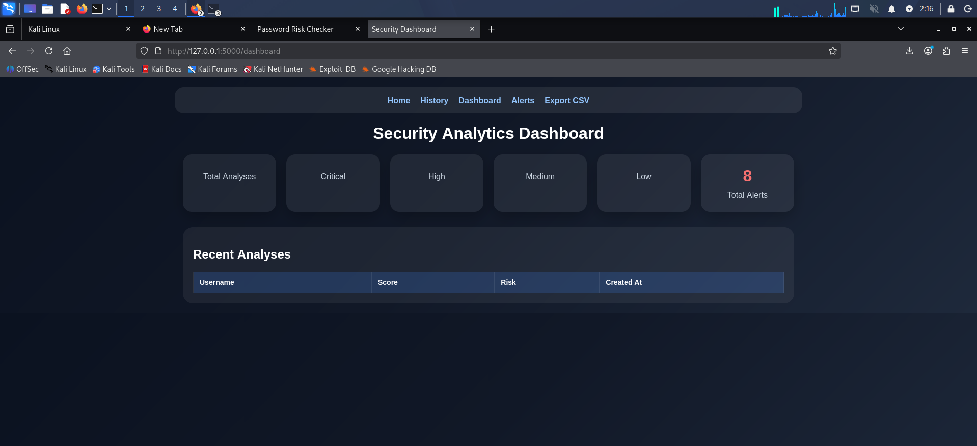
    - SYSTEM DASHBOARD / ANALYTICS


Figure 8.1.12: Dashboard Displaying System Security Metrics

8.2 SAMPLE CODING

    - FLASK BACKEND (MAIN APPLICATION -APP.PY)

rom flask import Flask, render_template, request, redirect, url_for
import sqlite3
from datetime import datetime

app = Flask(_name_)

# Temporary storage for login attempts
login_attempts = {}

# Password strength function
def check_password_strength(password):
score = 0

if len(password) >= 8:
score += 1
if any(char.isupper() for char in password):
score += 1
if any(char.islower() for char in password):
score += 1
if any(char.isdigit() for char in password):
score += 1
if any(char in "!@#$%^&*()" for char in password):
score += 1

if score <= 2:
return "Critical"
elif score == 3:
return "Medium"
elif score == 4:
return "High"
else:
return "Low"

# Home route
@app.route('/')
def home():
return render_template('index.html')

# Login route
@app.route('/login', methods=['POST'])
def login():
username = request.form['username']
password = request.form['password']

correct_username = "admin"
correct_password = "Admin@123"

if username not in login_attempts:
login_attempts[username] = 0

if username == correct_username and password == correct_password:
login_attempts[username] = 0
return "Login Successful"

else:
login_attempts[username] += 1
attempts = login_attempts[username]

if attempts >= 3:
save_alert(username, "Multiple Failed Login Attempts")
return f"Login Failed! Attempts: {attempts} (ALERT TRIGGERED)"

return f"Login Failed! Attempts: {attempts}"

# Alert saving function
def save_alert(username, event):
conn = sqlite3.connect('database.db')
cursor = conn.cursor()

cursor.execute("""
CREATE TABLE IF NOT EXISTS alerts (
id INTEGER PRIMARY KEY AUTOINCREMENT,
username TEXT,
event TEXT,
time TEXT
)
""")

cursor.execute("INSERT INTO alerts (username, event, time) VALUES (?, ?, ?)",
(username, event, datetime.now()))

conn.commit()
conn.close()

# Run app
if _name_ == '_main_':
app.run(debug=True)

CODE EXPLANATION

- IMPORT STATEMENTS
from flask import Flask, render_template, request, redirect, url_for
import sqlite3
from datetime import datetime

Explanation:
These lines import the required libraries. Flask is used to create the web application and handle routing. SQLite3 is used for database operations, and datetime is used to record timestamps for alerts.

- FLASK APP INTIALIZATION
app = Flask(_name_)

Explanation:
This line initializes the Flask application. It creates the main app instance that will handle all incoming requests and responses

- LOGIN ATTEMPT STORAGE
login_attempts = {}

Explanation:
A dictionary is used to store the number of failed login attempts for each user. This helps in tracking suspicious behavior.

- PASSWORD STRENGTH FUNCTION
def check_password_strength(password):

Explanation:
This function evaluates password strength based on multiple conditions such as length, uppercase letters, lowercase letters, numbers, and special characters

- Password Evaluation Logic
if len(password) >= 8:
score += 1

Explanation:
Each condition increases the score. Based on the score, the password is classified into risk levels like Critical, Medium, High, or Low.

- Home Route
@app.route('/')
def home():
return render_template('index.html')

Explanation:
This defines the homepage of the application. It renders the main user interface where users interact with the system.

- Login Route
@app.route('/login', methods=['POST'])
def login():

Explanation:
This route handles login requests. It processes user input and validates credentials.

    - FRONTEND IMPLEMENTATION

<!DOCTYPE html>
<html lang="en">
<head>
<meta charset="UTF-8">
<title>Password Security Checker</title>
<style>
body {
font-family: Arial;
background: linear-gradient(to right, #141e30, #243b55);
color: white;
text-align: center;
}

.container {
margin-top: 100px;
}

input {
padding: 10px;
margin: 10px;
width: 250px;
border-radius: 5px;
border: none;
}

button {
padding: 10px 20px;
background-color: #00c6ff;
border: none;
border-radius: 5px;
cursor: pointer;
}

#strength {
margin-top: 10px;
font-weight: bold;
}

.weak { color: red; }
.medium { color: orange; }
.strong { color: green; }
</style>
</head>

<body>

<div class="container">
<h1>Password Strength Checker</h1>

<input type="text" id="username" placeholder="Enter Username"><br>
<input type="password" id="password" placeholder="Enter Password" onkeyup="checkStrength()"><br>

<div id="strength"></div>

<button onclick="login()">Login</button>

<p id="result"></p>
</div>

<script>
function checkStrength() {
let password = document.getElementById("password").value;
let strengthText = document.getElementById("strength");

let score = 0;

if (password.length >= 8) score++;
if (/[A-Z]/.test(password)) score++;
if (/[a-z]/.test(password)) score++;
if (/[0-9]/.test(password)) score++;
if (/[!@#$%^&*]/.test(password)) score++;

if (score <= 2) {
strengthText.innerHTML = "Weak Password";
strengthText.className = "weak";
} else if (score == 3) {
strengthText.innerHTML = "Medium Password";
strengthText.className = "medium";
} else {
strengthText.innerHTML = "Strong Password";
strengthText.className = "strong";
}
}

function login() {
let username = document.getElementById("username").value;
let password = document.getElementById("password").value;

fetch('/login', {
method: 'POST',
headers: { 'Content-Type': 'application/x-www-form-urlencoded' },
body: username=${username}&password=${password}
})
.then(response => response.text())
.then(data => {
document.getElementById("result").innerText = data;
});
}
</script>

</body>
</html>

CODE EXPLANATION

- HTML Document Structure
HTML
<!DOCTYPE html>
<html lang="en">
<head>

Explanation:
This section defines the basic structure of the webpage using HTML5 standards. The <!DOCTYPE html> declaration ensures that the browser renders the page in standards-compliant mode. The <html> tag specifies the language of the document, improving accessibility and SEO. The <head> section contains metadata, title, and styling information required for the webpage.

- Meta and Title Configuration
HTML
<meta charset="UTF-8">
<title>Password Security Checker</title>

Explanation:
The meta tag defines the character encoding used in the document, ensuring proper display of text and symbols. The title tag sets the name of the webpage, which appears in the browser tab and helps users identify the page.

- CSS Styling Section
HTML
body {
font-family: Arial;
background: linear-gradient(to right, #141e30, #243b55);
Explanation:
This section defines the visual appearance of the webpage using CSS. The font family is set for readability, and a gradient background is applied to enhance aesthetics. Styling plays a crucial role in improving user experience by making the interface visually appealing and easy to use.
- Additional styling elements include:
- Center alignment of content for better layout
- Padding and margins for spacing
- Button styling for interactivity
- Color coding for password strength indication

- Container Division
HTML
<div class="container">

Explanation:
The container class is used to group all UI elements together. It helps in maintaining a structured layout and ensures that all components are aligned properly on the screen. This improves readability and user interaction.

- Input Fields for User Credentials
HTML
<input type="text" id="username" placeholder="Enter Username">
<input type="password" id="password">

Explanation:
These input fields allow users to enter their credentials. The password field masks the entered characters to maintain confidentiality. The use of placeholders improves usability by guiding users on what to enter.
- Key points:
- Ensures user input collection
- Provides basic security through hidden password input
- Enhances user guidance

- Real-Time Event Trigger
HTML
onkeyup="checkStrength()"

Explanation:
This event listener triggers the password strength evaluation function whenever a key is released. It enables real-time analysis of the password, allowing users to see immediate feedback without submitting the form.
This improves:
- User experience
- Efficiency
- Security awareness

- Password Strength Display Element
HTML
<div id="strength"></div>

Explanation:
This element dynamically displays the password strength result. It is updated by JavaScript based on the evaluation of the entered password.

- JavaScript Function – Password Strength Logic
JavaScript
function checkStrength() {

Explanation:
This function is responsible for analyzing the password strength in real time. It calculates a score based on predefined conditions and updates the UI accordingly.

    - DATABASE AND ALERT MANAGEMENT CODE

import sqlite3
from datetime import datetime

def init_db():
conn = sqlite3.connect('database.db')
cursor = conn.cursor()

cursor.execute("""
CREATE TABLE IF NOT EXISTS alerts (
id INTEGER PRIMARY KEY AUTOINCREMENT,
username TEXT,
event TEXT,
time TEXT
)
""")

conn.commit()
conn.close()

def save_alert(username, event):
conn = sqlite3.connect('database.db')
cursor = conn.cursor()

cursor.execute("INSERT INTO alerts (username, event, time) VALUES (?, ?, ?)",
(username, event, datetime.now()))

conn.commit()
conn.close()

def get_alerts():
conn = sqlite3.connect('database.db')
cursor = conn.cursor()

cursor.execute("SELECT * FROM alerts")
data = cursor.fetchall()

conn.close()
return data

CODE EXPLANATION

- Database Module Overview
The database module is responsible for storing, managing, and retrieving security-related data generated by the system. It plays a crucial role in maintaining persistent records of login attempts and alerts. This ensures that all system activities are logged and can be analyzed later.
Unlike temporary storage methods, the database provides long-term reliability and supports data-driven decision-making within the system.

- Importing Database and Time Modules
Python
import sqlite3
from datetime import datetime

Explanation:
The sqlite3 module is used to interact with the SQLite database, enabling operations such as table creation, data insertion, and retrieval. The datetime module is used to record the exact time when an alert is generated, which is essential for tracking and analysis.

- Database Initialization Function
Python
def init_db():

Explanation:
This function ensures that the required database structure is created before the system starts operating. It prevents errors related to missing tables and ensures that the system is ready to store alert data.

- Establishing Database Connection
Python
conn = sqlite3.connect('database.db')
cursor = conn.cursor()

Explanation:
This establishes a connection between the application and the database file. The cursor object is used to execute SQL queries. This step is mandatory for performing any database operation.
The connection is lightweight and efficient, making SQLite suitable for small-scale applications.

- Table Creation with Safety Check
Python
CREATE TABLE IF NOT EXISTS alerts (

Explanation:
This SQL statement creates the alerts table only if it does not already exist. This prevents duplication errors and ensures that the table is created safely during multiple executions.

- Table Schema Design
Python
id INTEGER PRIMARY KEY AUTOINCREMENT,
username TEXT,
event TEXT,
time TEXT

Explanation:
- The schema defines the structure of the alerts table:
- id → uniquely identifies each record
- username → identifies the user associated with the alert
- event → describes the type of suspicious activity
- time → records when the event occurred
- This structured format ensures efficient storage and retrieval of data.

- Transaction Management
Python
conn.commit()
conn.close()

Explanation:
The commit() function saves all changes made during the transaction to the database. Without this, data would not be permanently stored. The close() function terminates the database connection, freeing system resources and ensuring proper cleanup.

- Alert Saving Function
Python
def save_alert(username, event):

Explanation:
This function is responsible for storing alert data whenever suspicious activity is detected. It encapsulates the logic required for inserting records into the database.

    - SYSTEM INTEGRATION

- Overview of System Integration
The system is designed using a modular architecture where the frontend, backend, and database components work together to provide complete functionality. Each component performs a specific role, and their integration ensures smooth execution of the application.

The frontend handles user interaction, the backend processes logic, and the database stores data. The communication between these components is achieved through HTTP requests and database queries.

- Frontend to Backend Communication
JavaScript
fetch('/login', {

Explanation:
The frontend sends user input (username and password) to the backend using an HTTP POST request. This enables real-time interaction between the user interface and server-side logic.

- Data Flow from User Input
Explanation:
The process begins when the user enters credentials in the interface. The password is first analyzed on the frontend for strength, and then the data is sent to the backend for authentication.
Flow:

User Input → JavaScript → Flask Backend

- Backend Processing Logic
Python
@app.route('/login', methods=['POST'])

Explanation:
The backend receives the request and processes the input. It validates the credentials and determines whether the login attempt is successful or failed.

- Login Monitoring Integration
Python
login_attempts[username] += 1

Explanation:
The system tracks failed login attempts for each user. This integration ensures that repeated failures are monitored and evaluated for suspicious activity.

- Alert Generation Integration
Python
save_alert(username, "Multiple Failed Login Attempts")

Explanation:
When the number of failed attempts exceeds the threshold, the backend triggers the alert system. This connects the login module with the alert management module.

- Backend to Database Communication
Python
conn = sqlite3.connect('database.db')

Explanation:
The backend communicates with the database to store alert data. This ensures that all suspicious activities are recorded permanently.

- Data Storage Flow
Explanation:
The generated alert is stored in the database with relevant details such as username, event type, and timestamp.
Flow:

Backend → Database → Alert Stored

- Data Retrieval for Dashboard
Python
cursor.execute("SELECT * FROM alerts")

Explanation:
The system retrieves stored data from the database to display it in the alerts dashboard. This enables users to monitor system activity.

- Backend to Frontend Response
JavaScript
.then(response => response.text())

Explanation:
The backend sends a response (success/failure message) to the frontend, which is then displayed to the user.

- Complete System Flow
Explanation:
The entire system operates in a continuous cycle:

User → Frontend → Backend → Database → Backend → Frontend → User
This ensures real-time interaction and efficient processing.

  - USER DOCUMENTATION

8.3.1 Introduction
The user documentation provides a detailed guide on how to use the Password Strength Analysis and Login Security Monitoring System. It helps users understand the functionality of the system and how to interact with its features effectively.

8.3.2 System Requirements
- Operating System: Windows / Linux (Kali Linux recommended)
- Browser: Google Chrome / Mozilla Firefox
- Software: Python 3.x, Flask
- Database: SQLite

8.3.3 Installation Steps
- Install Python and required libraries
- Install Flask using:
- Bash
- pip install flask
- Place project files in a directory
- Open terminal and navigate to project folder
- Run the application:
- Bash
- python app.py
8.3.3 Steps to Use the System
Step 1: Launch Application
Run the Flask server
Open browser and go to http://127.0.0.1:5000

Step 2: Enter Credentials
Input username and password in the fields

Step 3: Password Strength Analysis
System evaluates password in real time
Displays strength level (Weak / Medium / Strong)

Step 4: Attempt Login
Click on login button
System validates credentials

Step 5: Observe Login Behavior
Successful login → access granted
Failed login → attempt count increases

Step 6: Alert Generation
After multiple failed attempts → alert triggered

Step 7: View Alerts
Navigate to alerts dashboard
View stored suspicious activities

Step 8: Export Data
Export results as CSV file

EFERENCES

BOOK REFERENCES
- William Stallings, Cryptography and Network Security: Principles and Practice, 7th Edition, Pearson Education, 2017.

- Behrouz A. Forouzan, Data Communications and Networking, 5th Edition, McGraw-Hill Education, 2013.

- Mark Lutz, Learning Python, 5th Edition, O’Reilly Media, 2013.

- Al Sweigart, Automate the Boring Stuff with Python, No Starch Press, 2015.

  - WEB REFERENCE

- Flask Documentation – https://flask.palletsprojects.com/⁠�

- Python Official Documentation – https://www.python.org/doc/⁠�

- Mozilla Developer Network (MDN) – https://developer.mozilla.org/⁠�

- W3Schools Web Development Tutorials – https://www.w3schools.com/⁠�

- OWASP Official Website – https://owasp.org/⁠�

